PROJECT REPORT

PROJECT INFORMATION
Project Title - Retail Performance Analysis
Student Name(s) – Archita Prakash , Ishita Nath, Kanika
Enrollment Number(s) -065013, 065026, 065029
Group Number-7
Data Description:
1. Dataset Overview
· File Name : ap_13_in_26_kk_29.xlsx
· Dataset Name : Retail Transactional Data
· Dataset Source: Kaggle
· Dataset Type: Time Series
· File Type : CSV
· File Size : 279MB
· Data Dimension
Records : 2944
Attributes : 31
· Attribute Types : Categorical & Non-categorical

Categorical | Non-Categorical
Age | Transaction_ID
City | Customer_ID
State | Name
Country | Email
Gender | Phone
Income | Address
Customer_Segment | Time
Zipcode | Total Purchases_Amount
Date | Total_Amount
Year
Month
Product_Category
Product_Brand
Product_Type
Feedback
Shipping_Method
Payment_Method
Order_Status
Ratings

Nominal | Ordinal
Customer_Segment | Age
City | Date
State | Ratings
Country
Gender
Income
Zipcode
Date
Year
Month
Product_Category
Product_Brand
Product_Type
Feedback
Shipping_Method
Payment_Method
Order_Status

Index | Non-Index
Transaction_ID | Name
Customer_ID | Email
 | Phone
 | Address
 | Time
 | Total Purchases_Amount
 | Total_Amount

Variables | Text/Number
Transaction_ID | Number(Integer)
Customer_ID | Number(Integer)
Name | Text
Email | Text
Address | Text
Phone | Number (Integer)
City | Text
State | Text
Zipcode | Number (Integer)
Country | Text
Age | Number (Integer)
Gender | Text
Income | Text
Customer_Segment | Text
Date | Number(Integer)
clean_date | Number(Integer)
Year | Number(Integer)
Month | Text
Time | Number(Decimal)
Total_Purchases | Number(Integer)

BASIC STATS
Variable | Count
Transaction_ID | 294461
Customer_ID | 86555
Name | 157552
Email | 52631
Phone | 294110
Address | 294138
City | 131
State | 55
Zipcode | 93718
Country | 6
Age | 54
Gender | 3
Income | 4
Customer_Segment | 4
Date | 367
clean_date | 32
Year | 3
Month | 13
Time | 83507
Total_Purchases | 11
Amount | 294108
Total_Amount | 294115
Product_Category | 6
Feedback | 5
Shipping_Method | 4
Payment_Method | 5
Order_Status | 5
Ratings | 6
products | 318

Category | Frequency | Proportion
Australia | 43961 | 14.93%
Canada | 43935 | 14.92%
Germany | 51456 | 17.47%
UK | 61698 | 20.95%
USA | 93145 | 31.63%
NA | 266 | 0.09%
Male | 182869 | 62.10%
Female | 111282 | 37.79%
NA | 310 | 0.11%
High | 73408 | 24.93%
Medium | 127236 | 43.21%
Low | 93535 | 31.76%
NA | 282 | 0.10%
New | 88778 | 30.15%
Regular | 143221 | 48.64%
Premium | 62254 | 21.14%
NA | 208 | 0.07%
Books | 53202 | 18.07%
Clothing | 53397 | 18.13%
Electronics | 69420 | 23.58%
Grocery | 65192 | 22.14%
Home Décor | 52975 | 17.99%
NA | 275 | 0.09%
Excellent | 98336 | 33.40%
Good | 92840 | 31.53%
Average | 61021 | 20.72%
Bad | 42084 | 14.29%
NA | 180 | 0.06%
Standard | 92801 | 31.52%
Express | 99763 | 33.88%
Same-day | 101567 | 34.49%
NA | 330 | 0.11%
Cash | 71217 | 24.19%
Debit Card | 75431 | 25.62%
Credit Card | 87465 | 29.70%
PayPal | 60058 | 20.40%
NA | 290 | 0.10%
Delivered | 127892 | 43.43%
Shipped | 63216 | 21.47%
Processing | 55580 | 18.88%
Pending | 47541 | 16.15%

2. Project Objective:
This project involved analysing a large-scale retail transaction dataset to uncover actionable insights related to customer behaviour, product performance, and operational efficiency. Using advanced Excel functions across statistical, logical, and lookup categories, a dynamic customer dashboard was developed to enable individual-level analysis. Key metrics such as total spend, average ratings, and purchase preferences were derived using formulas like INDEX MATCH, COUNTIF, AVERAGE etc. Dropdown menus allowed users to select specific customers and view their detailed purchase records and feedback. The project also explored patterns across income groups, product categories, and feedback sentiment. Overall, the analysis enables targeted decision-making for marketing, inventory, and customer engagement strategies.

3.Analysis of Data
Excel Formulas & Functional Logic Used
To display email:
=INDEX(Table157[Email],MATCH(S7,Table157[Customer_ID],0))
To display Phone:
=INDEX(Table157[Phone],MATCH(S7,Table157[Customer_ID],0))
To Product Brand:
=INDEX(Table157[Product_Brand],MATCH(S7,Table157[Customer_ID],0))
Customer Dashboard Walkthrough (Screenshots):
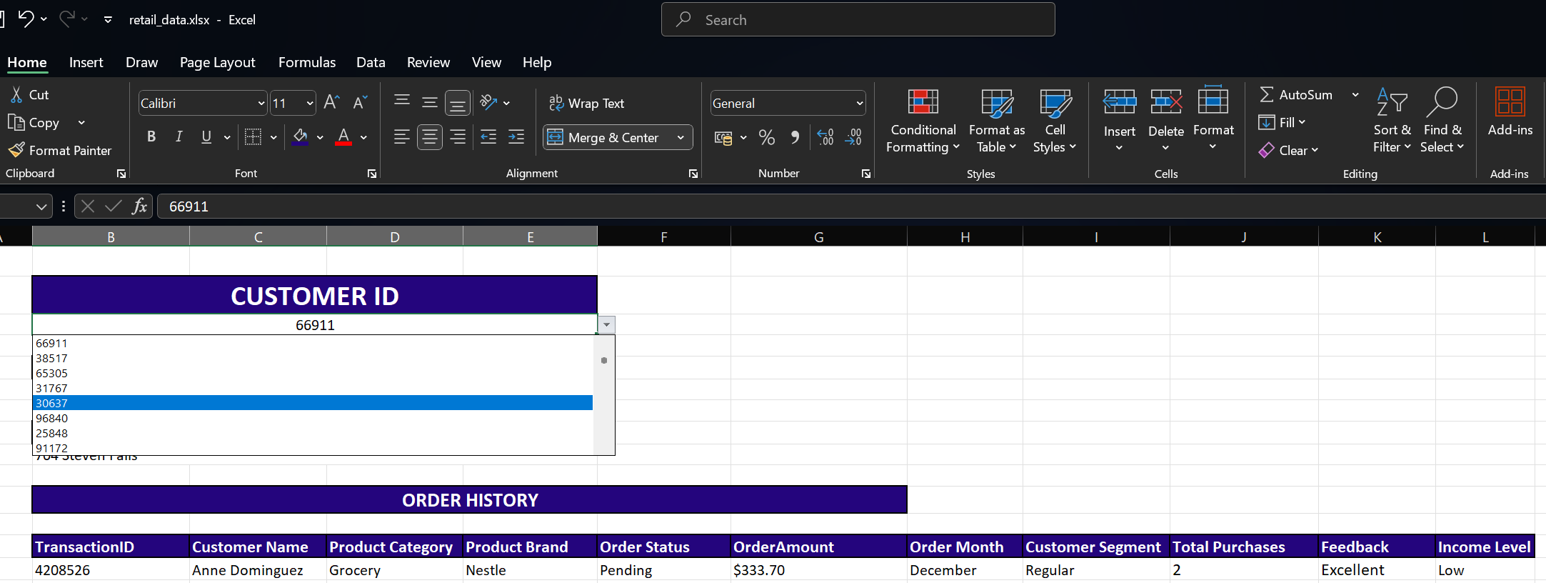
Figure: Customer ID selected using a data validation dropdown to dynamically update the dashboard.

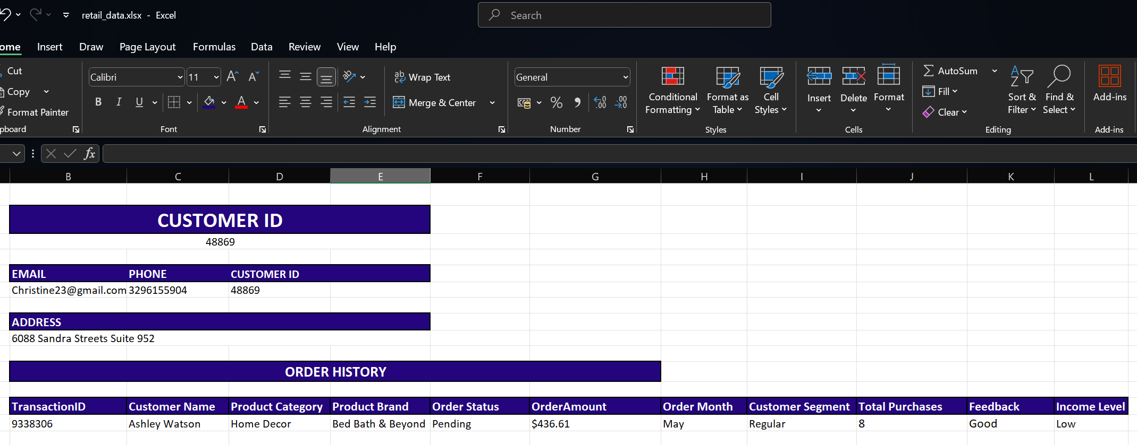
Figure: Dashboard view for Customer ID 48869 showing transaction summary, feedback, and purchase behavior.

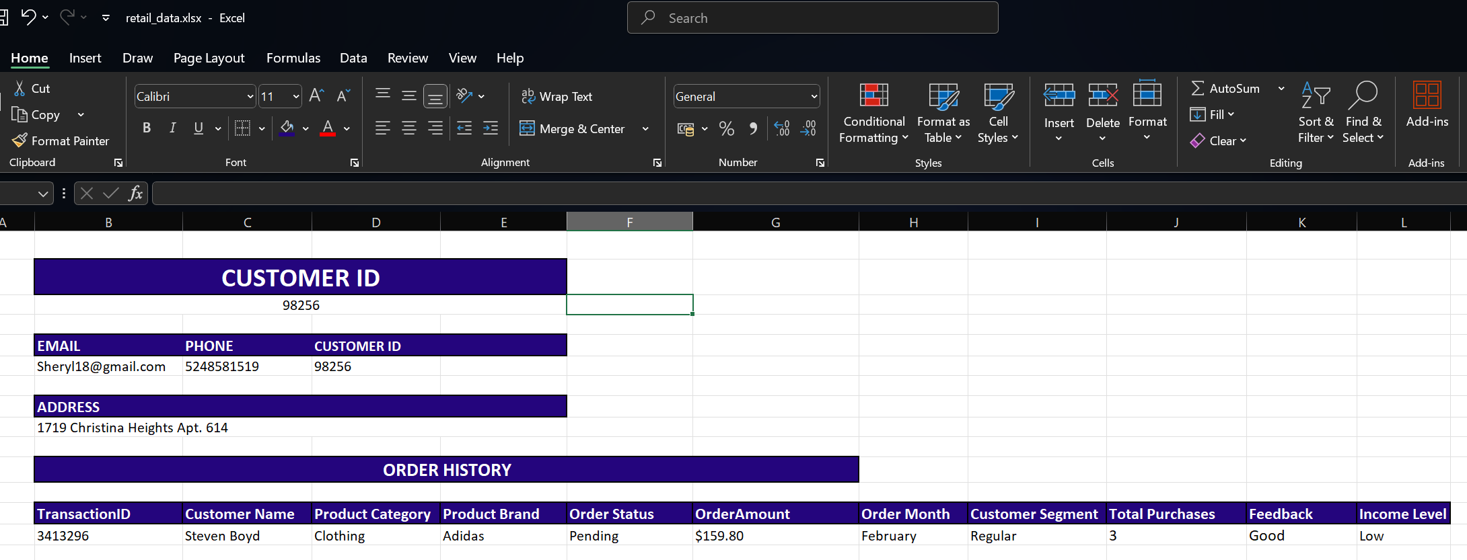
Figure: Dashboard view for Customer ID 98256 showing transaction summary, feedback, and purchase behavior.

- Observations for High-Value Customer Example “Emma Palmer”:
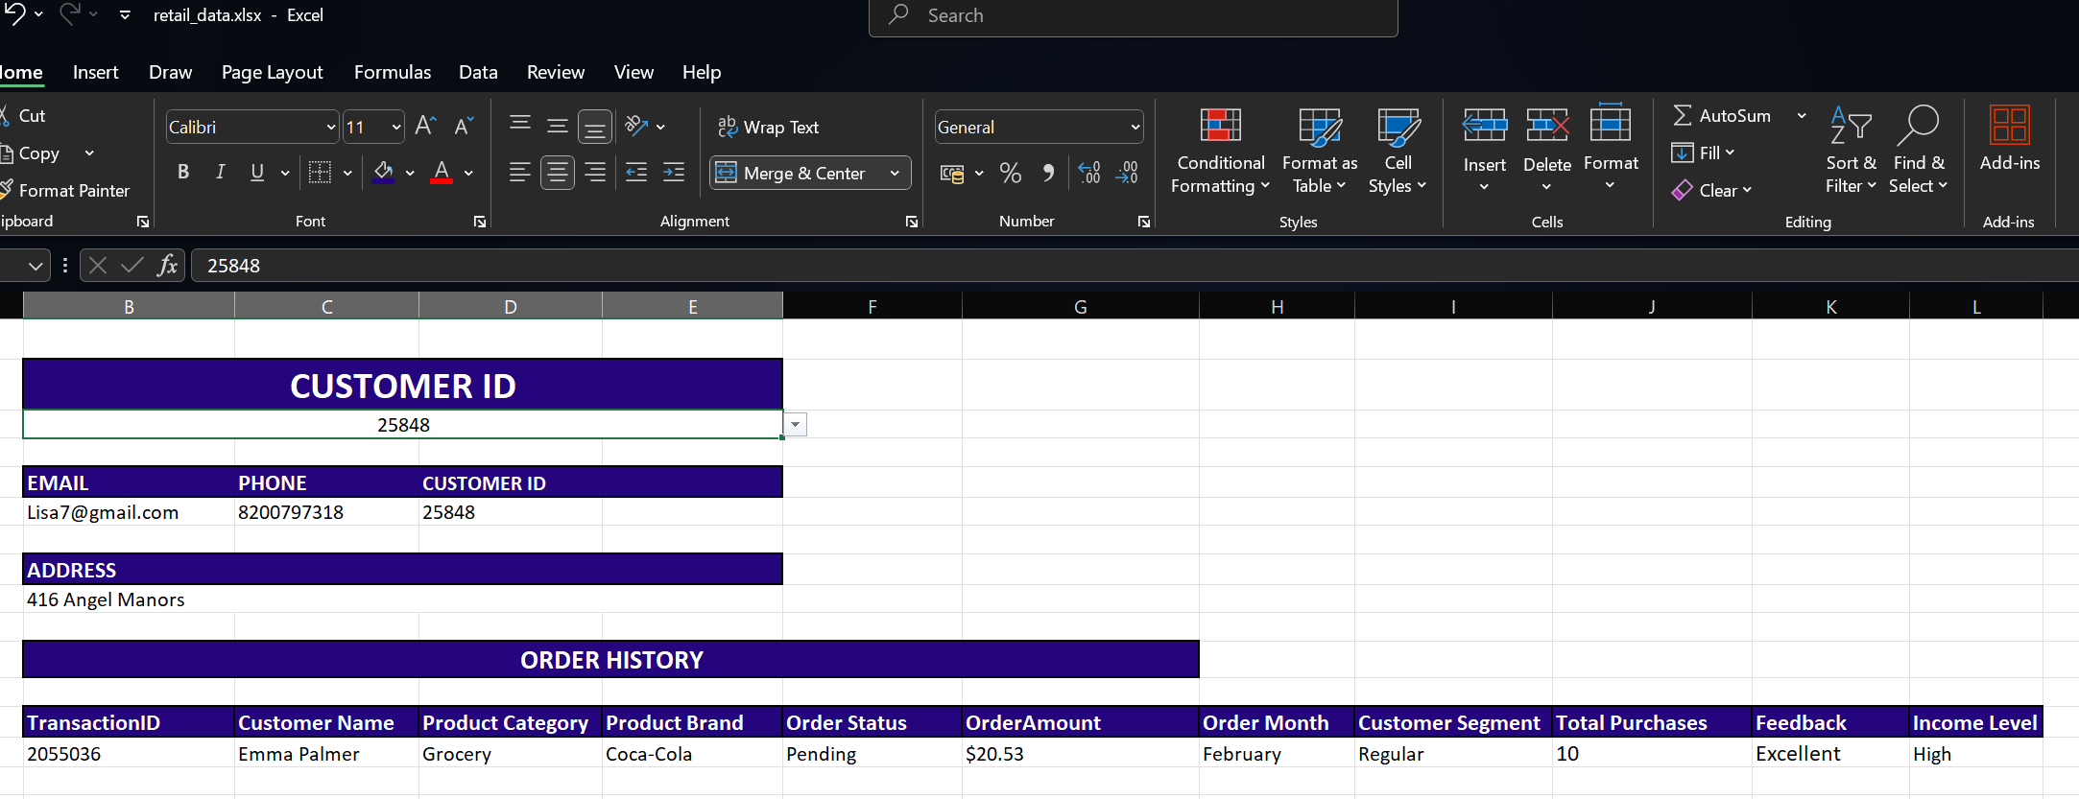

1. High Purchase Volume for Coca-Cola
Emma ordered 10 units, which suggests either bulk buying behavior or brand loyalty.
2. Positive Customer Sentiment
The "Excellent" feedback indicates high satisfaction, either with the product, service, or both.
3. High-Income Profile
She may have more disposable income to spend on branded or bulk goods.

- Managerial Insights
- Identify and Nurture High-Value Customers
Emma represents a segment that not only buys in larger quantities but also provides positive feedback.
Action: Add to loyalty program or VIP segment.
- Brand Affinity Insight – Coca-Cola
Coca-Cola may be a high-performing product among premium customers.
Action: Feature Coca-Cola in premium bundle offers or upselling campaigns.
- Targeted Marketing Opportunity
High-income customers with positive sentiment are ideal for cross-selling or exclusive promotions.
Action: Run targeted ads or personalized email campaigns for similar customers.
- Logistics and Inventory Strategy
Bulk orders by high-value customers can inform stocking strategies for fast-moving SKUs.
Action: Ensure stock availability of Coca-Cola in premium zones.
- Feedback-Driven Quality Benchmarking
Excellent feedback from such customers helps benchmark product performance.
Action: Use her feedback in testimonials or quality reviews.

ANALYSIS OF CHARTS

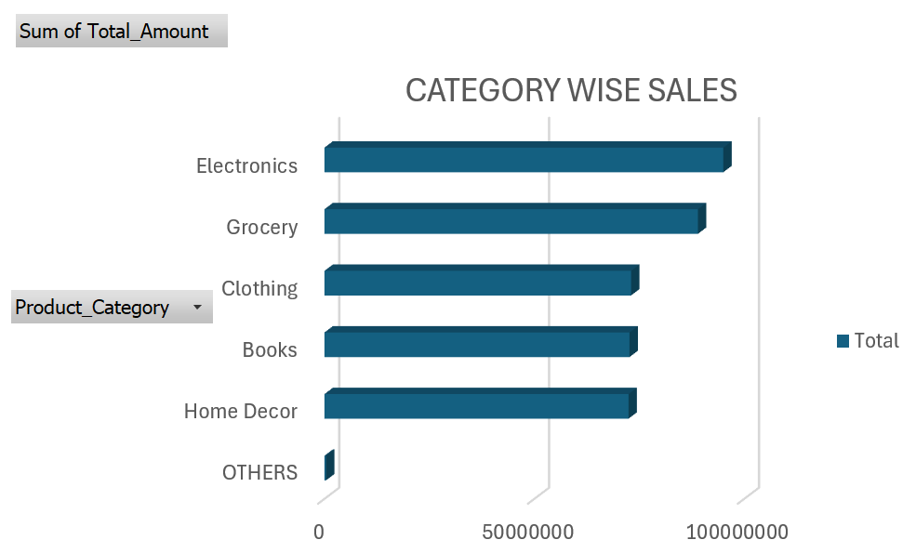

Key Observations:
1.Dominant categories
Electronics, Grocery, and Home Décor have the largest totals (all within about 10 million).
There are Clothing and Books coming up a little behind, but still notable.
Others has a very small contribution (negligible).

2. Distribution:
There is a fairly even distribution in Electronics, Grocery, and Home Décor.
Others has the very little contribution.

Managerial Insights:

1. Revenue Drivers
- Electronics, Grocery, and Home Décor are the key revenue generators.
- These categories should be maintained as strategic priorities for sales and marketing investments.

2. Growth Opportunities
- Promotions:
Use discounts, seasonal offers, or combos to push Books and Clothing.
- Market Research:
Understand why “Others” is underperforming—customer demand or lack of awareness?
- Diversification:
Since top categories are close in revenue, spreading risk across them is essential.

3.Inventory and Operations Strategy
- Allocate more inventory and space to top-performing categories (Electronics, Grocery, Home Décor).

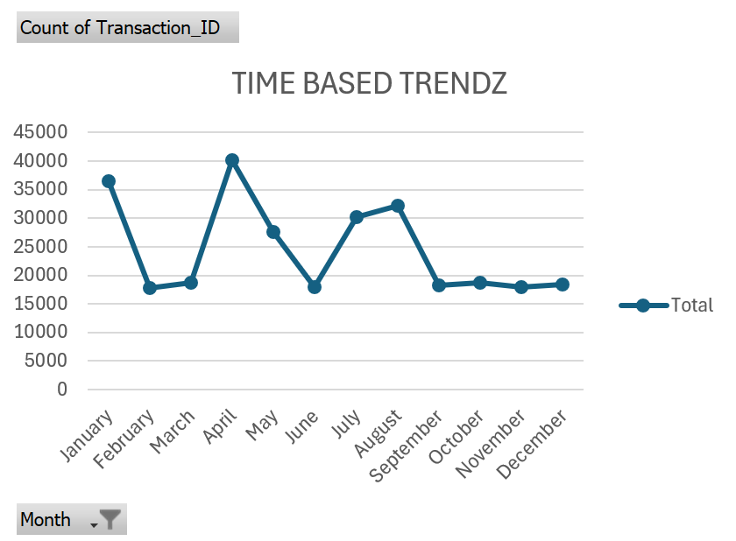

Observations
- Trend:
- High Activity: January, April, July, and August show peaks (highest in April).
- Low Activity: February, June, October to December show lower transaction counts.
- Stability:
- After September, the trend flattens with consistently low transactions.

3. Seasonality
- Strong seasonal peaks in April and mid-year (July–August).

6. Declining Year-End Activity
- October to December: Very low and stable transactions.

Managerial Insights:

1. Sales & Marketing Planning
- Demand Forecasting:
Use these patterns to plan inventory, marketing spend, and staffing based on seasonal spikes (April, July, August).
2. Operational Efficiency
Supply Chain Alignment:
Coordinate with suppliers in advance of high-demand months to prevent stockouts.

Long-Term Focus
- Trend Flattening at Year-End:
Persistent low levels from October to December indicate untapped opportunity. Explore festive shopping patterns, gift products, and collaborations for year-end growth.
- Predictive Analytics:
Use historical data to develop predictive models that anticipate surges and slumps more accurately.

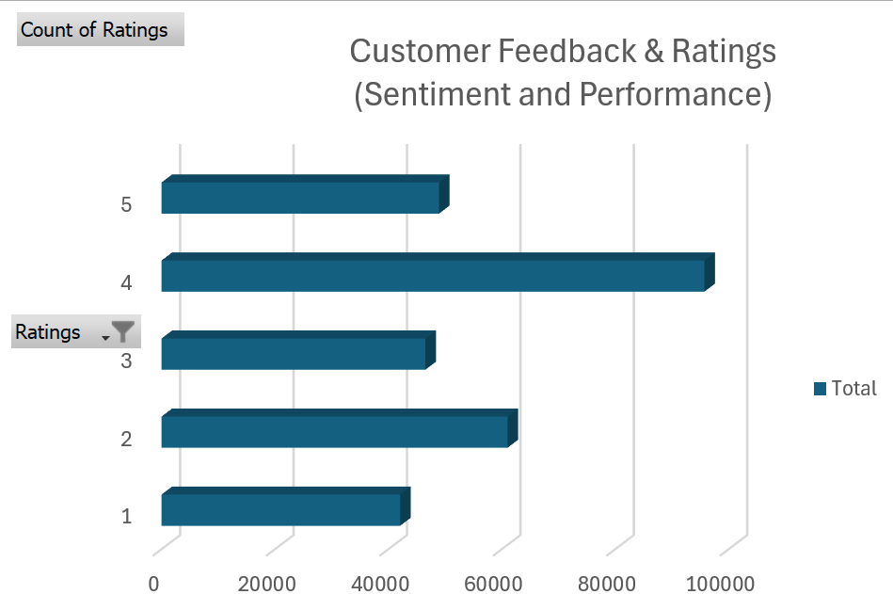

Observations

1. Strong Customer Satisfaction
- Majority ratings are 4 and 5, indicating overall customer satisfaction.
- Over 50% of the feedback is positive (4 & 5 stars).

2. Room for Improvement
- A significant volume of low ratings (1–3) highlights potential dissatisfaction areas that need action.

3. Low Rating Concerns
- Ratings of 1 and 2 together account for a large chunk of negative sentiment.
- These need root cause analysis (product quality, delivery, customer service).

Managerial Insights
- Enhance Customer Delight
- For 4-star reviewers, focus on improving service/product slightly to convert them into 5-star ratings.
- Reduce Negative Ratings
- Conduct root cause analysis of 1–2 star ratings through follow-ups, complaints data, and surveys.
- Introduce post-purchase support programs.
- Quality Monitoring
- Implement quality checks and feedback loops to ensure issues reflected in lower ratings are promptly addressed.

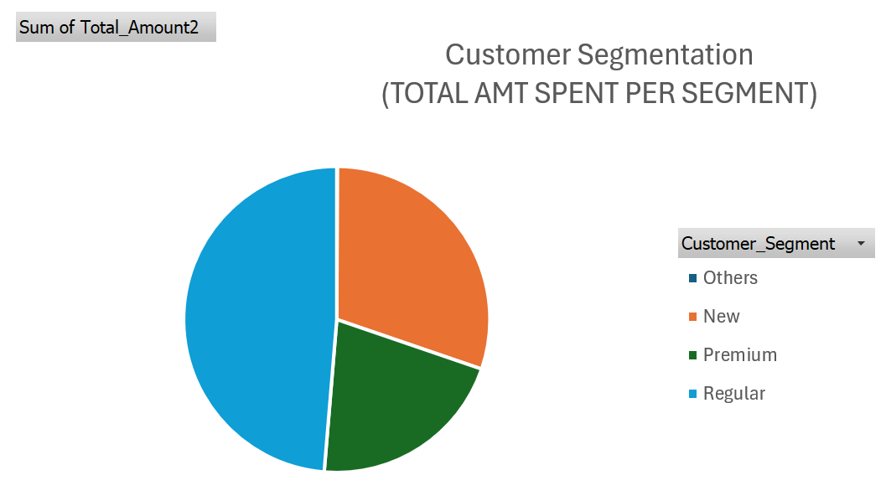

Observations
- Share by Total Amount:
- Regular customers have the largest share (almost half of the pie).
- New customers account for the second-largest share (around one-third).
- Premium customers form a smaller portion (around one-fifth).
- Others segment is extremely small, almost negligible.

2. Strong Dependence on Regular Customers
- Regular customers contribute the largest portion of revenue, indicating loyalty and repeat business as a key driver.

3. Healthy Share of New Customers
- New customers also represent a significant portion of revenue, showing successful acquisition efforts.

Managerial Insights
- Strengthen Regular Customers
- Continue loyalty programs, exclusive offers, and rewards to retain this high-value base.
- Convert New to Regular
- Introduce onboarding offers and personalized engagement to quickly move new customers into repeat purchase behavior.
- Expand Premium Segment
- Create exclusive premium services/products and focus on upselling strategies to grow revenue from high-value customers.

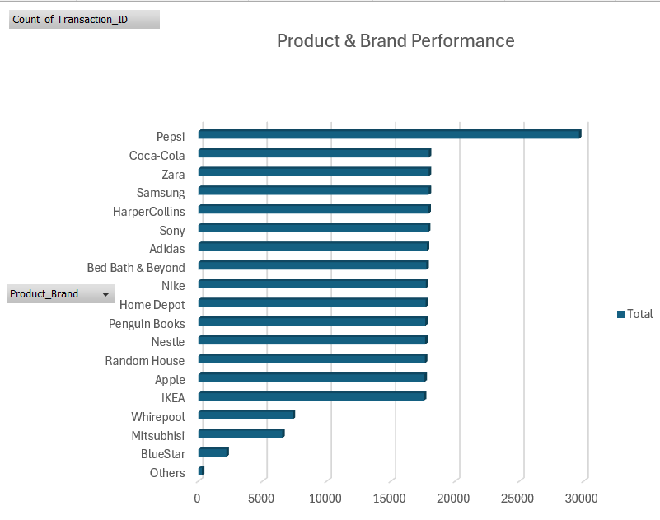
- Top Brand by Transactions:
  - Random House shows the highest number of transactions (close to 30,000).
- Strong Performing Brands:
  - Pepsi has highest transaction count .
  - Samsung, Sony,, Penguin Books, Nike, Apple, Adidas, Bed Bath & Beyond, Coca-Cola, HarperCollins, Home Depot, IKEA all have high transaction counts (15,000–20,000).
- Moderate Performers:
  - Whirlpool, Mitsubishi show mid-range transactions.
- Low Performers:
  - BlueStar has the lowest count.
- Negligible/NA:
  - NA (unbranded or unspecified) transactions are minimal.

Managerial Recommendations
- Leverage Top Brands
  - Partner with Random House, Samsung, Sony, and Penguin Books for co-marketing campaigns and exclusive launches.
- Focus on Underperforming Brands
  - Assess the reason for low transactions for BlueStar, Mitsubishi, Whirlpool. Consider repositioning or discontinuing if unprofitable.
3.Category-Specific Promotions
- Books and electronics clearly dominate; extend promotions and loyalty benefits to maximize retention in these categories.
4.Data-Driven Inventory Planning
- Use transaction patterns to prioritize inventory and supply chain readiness for top brands during peak months.

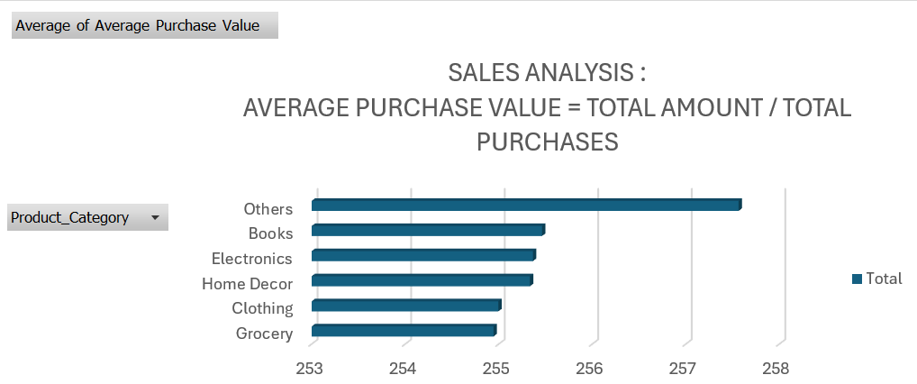

- Findings:
  - Among categories like Home Décor, Electronics, and Books have slightly higher values (~255.5).These categories tend to have higher value per transaction, consistent with larger item prices.
  - Grocery and Clothing have comparatively lower average purchase values (~255).
Mnagerial insights
Segment Targeting
- Focus marketing campaigns differently:
  - Value-driven offers for Grocery/Clothing
  - Premium experience and loyalty programs for Electronics/Home Décor

Long-Term Strategic Move
- Growth Areas:
  - Explore expansion of Home Décor and Electronics since customers already make larger purchases there.

4. Operational Focus
- Stock & Inventory:
  - High-value categories: Maintain limited but premium assortment.
  - Low-value categories: Focus on breadth, speed, and consistent availability.
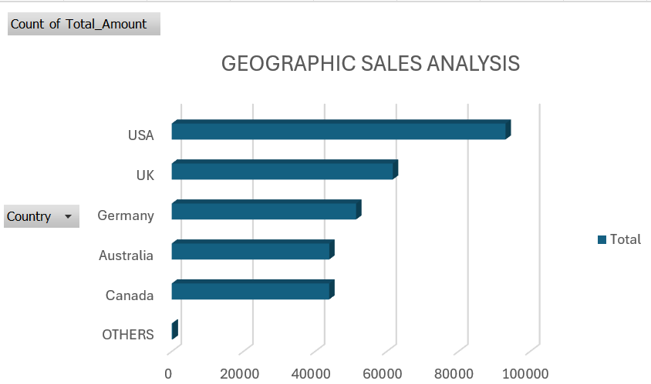

Top Performers:
- USA leads significantly with the highest count (around 95,000–100,000).
- UK follows with about 65,000 transactions.
Mid-Tier:
- Germany (~55,000), Canada (~45,000), Australia (~45,000).
Low Contribution:
- OTHERS category contributes very little.

3. Growth Opportunities
- Germany, Canada, and Australia have decent volumes but still underperform compared to USA/UK. These countries have potential for targeted campaigns.

Managerial Recommendations
- Protect & Expand USA Market
  - Maintain high investment in USA operations, loyalty programs, and customer retention, as it’s the core revenue generator.
- Accelerate Growth in UK
  - Target campaigns, product localization, and partnerships to narrow the gap with the USA.
- Unlock Potential in Germany, Canada, Australia
  - Localized marketing strategies, influencer campaigns, and regional partnerships to boost transactions.

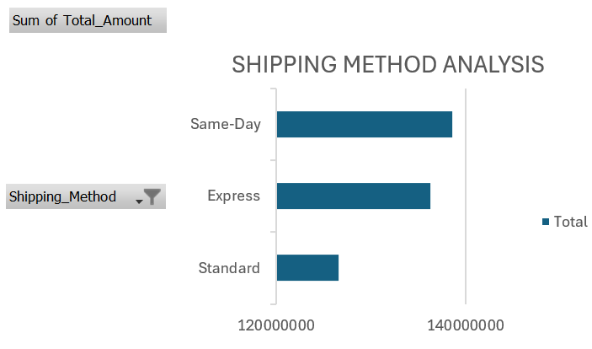

Findings:
- Same-Day shipping has the highest total amount (~138 million).
- Express shipping follows (~136 million).
- Standard shipping has the lowest (~126 million).

1. Customers Prefer Fast Delivery
- Higher total sales for Same-Day and Express suggest that customers are willing to pay more for faster delivery.

2. Speed as a Competitive Advantage
- Fast delivery seems to be a key driver of order value and customer satisfaction.

Managerial Insights

1. Profit Margin Optimization
- Same-Day shipping has higher logistics costs, so ensuring adequate delivery charges or bundling with high-margin products is critical to maintain profitability.
2.Standard Shipping Positioning
- Use Standard shipping primarily for cost-conscious or rural customers, focusing less on this option for urban/premium segments.

3.Customer Experience Differentiation
- Same-Day and Express delivery are driving higher revenue, which suggests customers value speed over cost.
- This is a competitive differentiator; companies can highlight “fast delivery promise” in marketing to attract premium customers.

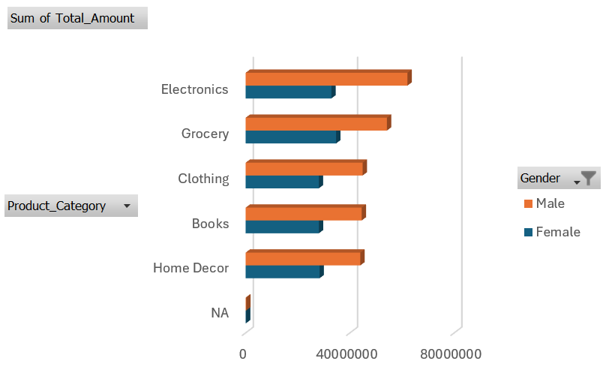

Observations
- Electronics Dominance
The Electronics category generates the highest total revenue, with sales significantly exceeding all other categories.
- Male Spending is Primary Driver:
Across all product categories, male customers consistently spend a substantially higher amount than female customers. The largest gender spending gap is in the Electronics category.
- Lower-Performing Categories:
The Clothing and Home Decor categories show the lowest total sales, falling below Books, Grocery, and Electronics.
- Consistent Female Spending:
Female spending is relatively stable across all product categories, with a less dramatic variance compared to male spending patterns.

Managerial Insights
1.Target Male Customers: Continue to focus marketing and product development on male customers, who are the primary drivers of revenue.
2.Increase Female Spending: Develop targeted campaigns and promotions to increase sales from female customers, especially in underperforming categories.
3.Leverage High-Performing Categories: Use cross-selling to boost sales in lower-performing categories by bundling them with strong-performing ones like Electronics.

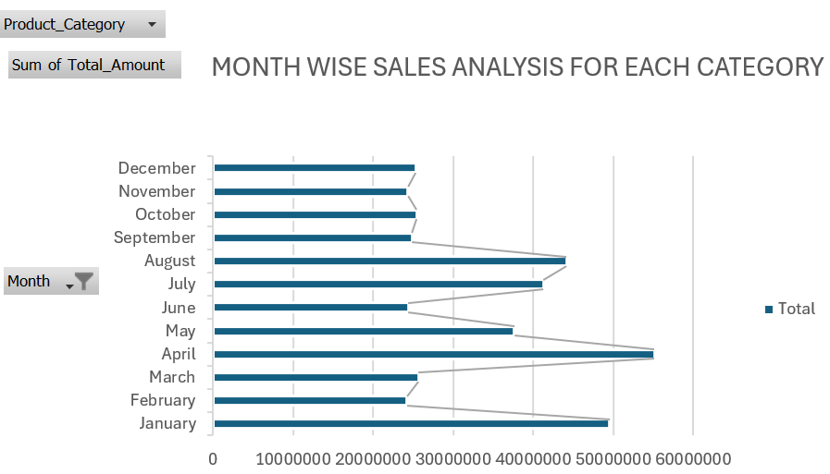

- Seasonal Peaks:
  - Two clear sales peaks are evident:
    - First peak: January and April (highest in April, over 55,000,000).
    - Second peak: Mid-year, particularly July and August (~40,000,000 each).
- Highest and Lowest Months:
  - April records the highest sales volume, followed by January.
  - Lowest performing months: September to December and February show the lowest transaction counts.
- Mid-Year Performance:
  - July and August mark a strong secondary growth period, suggesting mid-year campaigns or seasonal trends affect demand positively.
- Off-Season:
  - The final quarter (September–December) and February represent a consistent lull in sales, highlighting periods of low customer activity.

Managerial Insights
- Optimize Resources for Peak Seasons:
  - Increase inventory, logistics support, and staffing in January, April, July, and August to meet demand efficiently.
  - Align marketing campaigns and product launches to these months.
- Develop Off-Season Strategies:
  - Drive demand in low months (Feb, Sep–Dec) via:
Flash sales and discounts,Festive bundles or new product launches,Targeted digital campaigns
- Analyze Peak Drivers:
  - Identify root causes of April and January spikes (promotions, product launches, holidays, etc.).
- Forecast and Plan:
  - Use seasonal patterns for accurate forecasting and avoid stock-outs during peaks.

